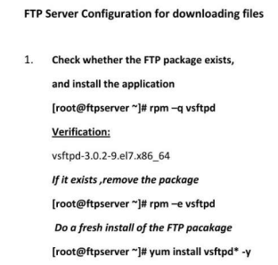

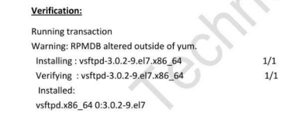

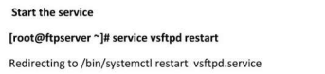



[root@ip-172-31-29-171 ftp]# useradd raj

[root@ip-172-31-29-171 ftp]# passwd raj

 [root@ip-172-31-29-171 ftp]# useradd talal

[root@ip-172-31-29-171 ftp]# passwd talal

[root@ip-172-31-29-171 ftp]# useradd fatima

[root@ip-172-31-29-171 ftp]# passwd fatima

[root@ip-172-31-29-171 ftp]# useradd latifa

[root@ip-172-31-29-171 ftp]# passwd latifa

FTP Client:

Install the filezilla application in windows computer.

Enter the username fatima  and password  1234 , port 21   on the filezilla client application in windows then verify the following things:

* Fatima will be able to transfer the data inside her on home  directory   /home/fatima

In the other directories she don’t have access.

Like wise for other users also have access in their own home directories...